Scope
Statement of what a particular 2Ps covers and what it does not cover. Most often, Scope is an expansion of the procedure title.
Sample:
This document covers the policies and procedures in requisition, approval, issuance and monitoring of parts.
Definition of Terms
A word or phrase used to describe a thing or to express a concept.
Sample:
MJOR – Material Job Order Requirement, form being used to request purchase of any item through Materials Management Department (MMD)

Ownership
Sample:
The Fleet Management Manager is responsible for ensuring that this document is cascaded to all concerned personnel and that it reflects actual practice.

Policies
A set of guiding principle which aims to consistently provide product and/or services that meet customer applicable and regulatory requirements.
Note:
- State each policy or rule that affects the performance of the activity
- Keep it brief.
- Policies must accurately and consistently answer inquiries.
- Statements must not start with a verb.
- Do not include justification or historical reasons for the policy

Procedures
Describes how activities specific to particular departments are performed. It demonstrates the step by step process of performing ways of doing things.
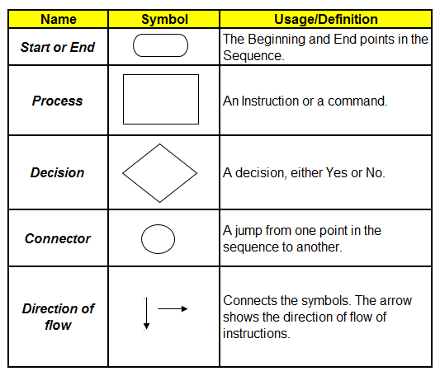
Sample: This is not yet finished. This is for your reference only.
